

TYPES OF INFORMATION

SYSTEMS

TYPES OF INFORMATION SYSTEMS

Transaction processing systems

Management information system and decision support systems
- Executive support system for senior management
- Office automation system
- Knowledge Management System

Transaction processing system

Transaction processing system is a type of information system . TPSs collect, store, modify and retrieve the transactions of an organization, A Transaction is an event that generates or modifies data that is eventually stored an information system.

E.g : Order entry system, cheque processing systems, accounts receivables systems, payroll systems and ticket
reservation systems

These systems help any company to conduct operations and keep track of its activities
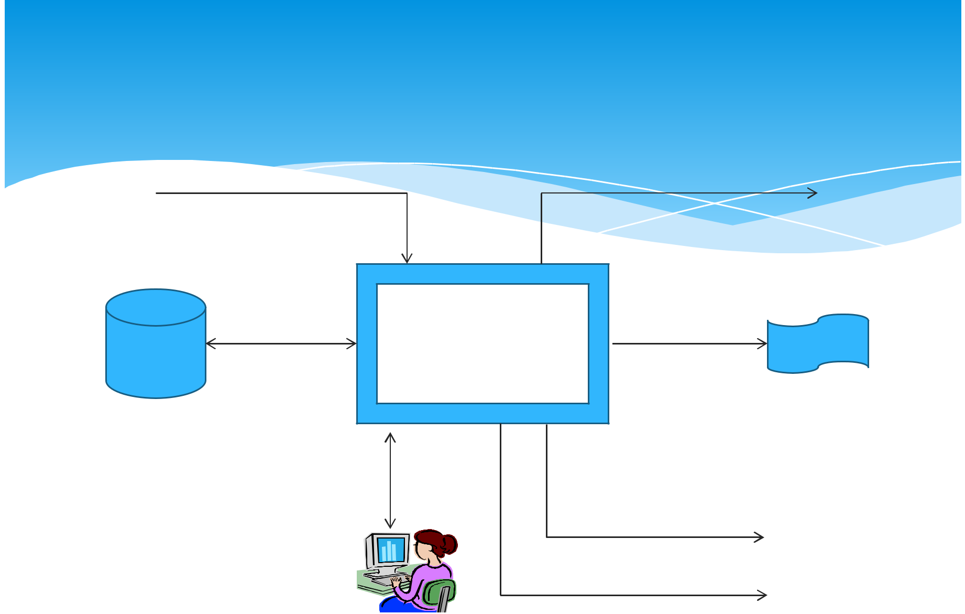
A PAYROLL TPS

To general ledger
EMPLOYEE DATA

Employee | Payroll
/file | System
database | System

 | Management
Employee number | reports
Address
Pa rate
Gross pay | To government
Federal tax | agencies
Medicare
State tax | Employee paychecks
Net pay | Employee paychecks

Online
queries

TPS CHARACTERISTICS

A TPS records internal and external transactions for a company. It is a repository of data that is frequently accessed by other systems

A TPS performs routine , repetitive tasks .It is mostly used by lower level managers to make operational decisions

Transactions can be recorded in batch mode or online.In batch mode the files are updated periodically.In online mode , each transaction is recorded as it occurs

There are six steps in processing a transaction.they are data entry ,data validation , data processing and revalidation , storage – output generation and query support
Objectives of TPS

- Process data generated by and about transactions

- Maintain a high degree of accuracy and integrity

- Avoid processing fraudulent transactions

- Produce timely user responses and reports

- Increase labor efficiency

- Help improve customer service

- Help build and maintain customer loyalty

- Achieve competitive advantage
TYPES OF TPS
Online system:

it involves a direct connection between the operator and TPS program , they provide immediate result eg . An order arrive by telephone call it is processed at that moment and results are produced
Batch processing:

it is the second type of TPS ,where transactions are grouped together and processed as a unit

for eg: a cheque proccesing system in a bank all the cheque received in a particular day are grouped together. They are then sorted by the account no and processed in a batch
More Examples
Batch transaction processing:

Cheque clearance :written order asking bank to pay money to a person

Bill generation : an invoice for general services provided to the customers
credit card sales transaction
Examples of real time transaction processing:
reservation systems; set aside service/product for future use
point -of-sale (POS) terminals ;sells goods/services
library loan system ; keeps track of items borrowed from library
Difference between real time and
Batch

Real time:

 each transaction is unique ; transactions are standlone; requires master file to be available more often for updating; fewer errors-transaction data is validated and entered immediately; infrequent errors may occur; not practical to shut down the whole system
Batch:

each transaction pat of a group; database not accessible all of the time; more errors; data is organized and stored before master file is updated -errors can occur during these steps; easier to maintain than real-time.
MIS

Designates a specific category of information systems serving middle management.

Provides middle managers with reports on organization’s current performance.

Information thus obtained is used to monitor and control and business and predict future
Characteristics of MIS

- MIS is an integrative system

- MIS is Sub System concept

- Provides relevant information to management

- MIS is flexible

- Enhances productivity

- Is a coordinated system

- Feedback system

TPS

Order
file

Production
Master
file

Accounting
file

 | MIS
 | MIS
Order | Sales
Processing | Sales
Processing | data
system | data
Materials | Unit | reports
Resource | Product | reports
Resource | Product | MIS
Resource | Cost data | MIS
Planning | Cost data | MIS
system
 | Product | managers
 | change
 | data
General
Ledger | Expense
system | Expense
system | data
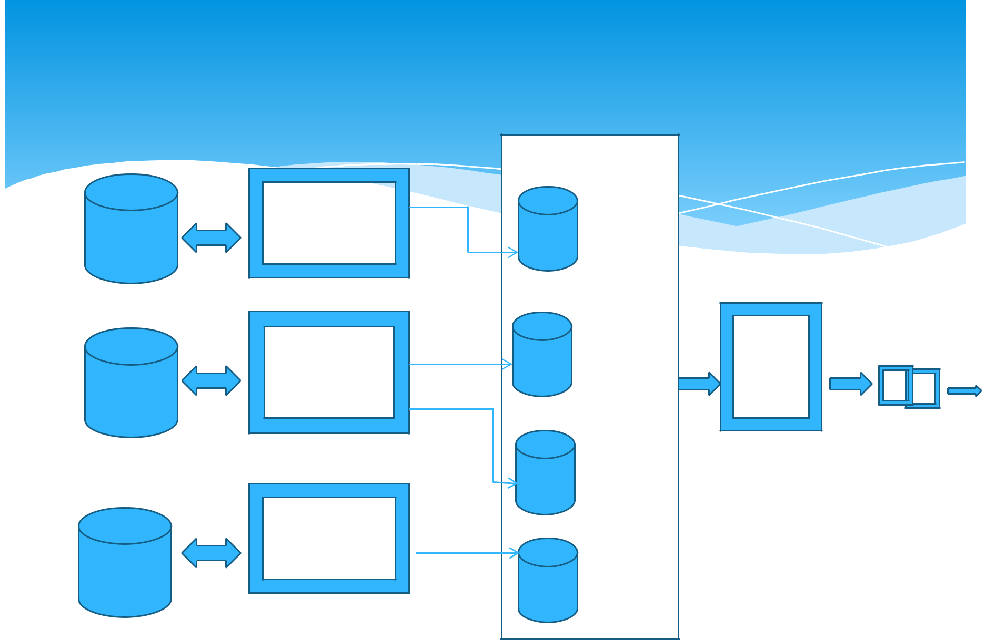
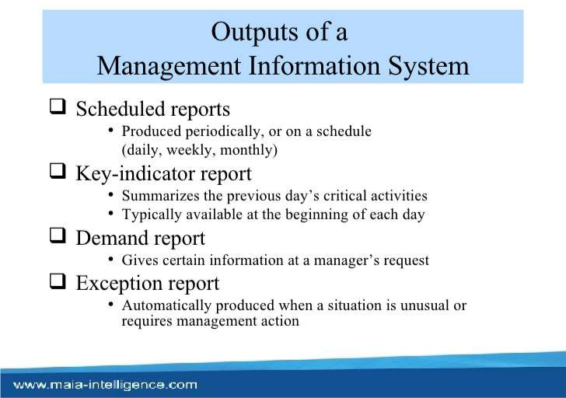
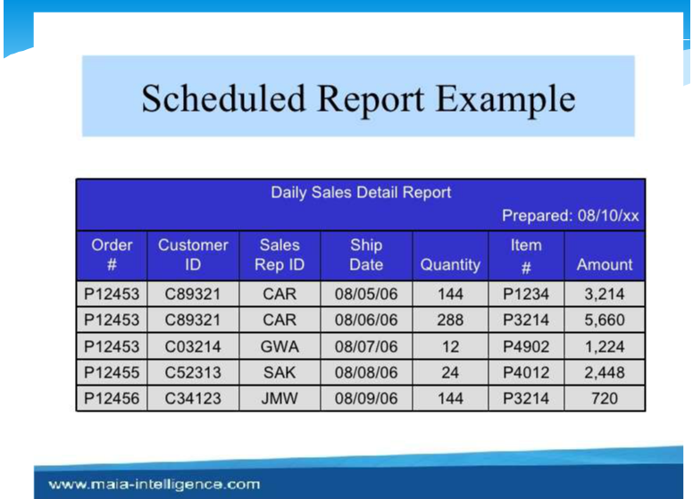
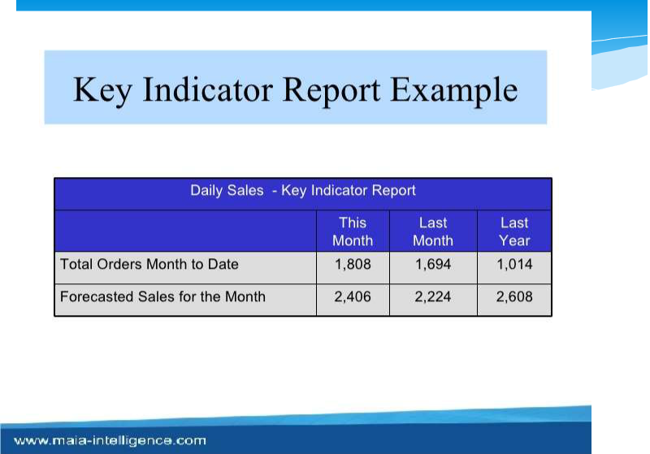
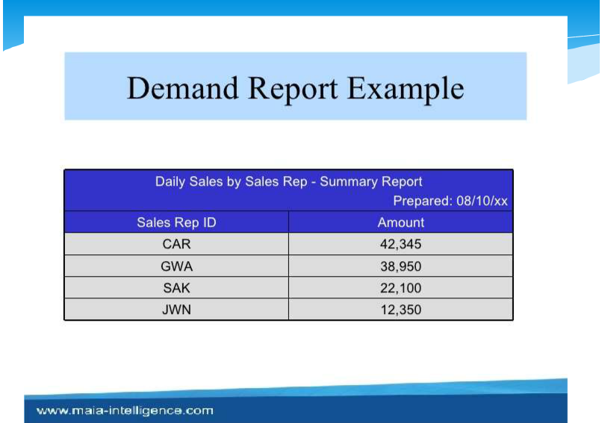
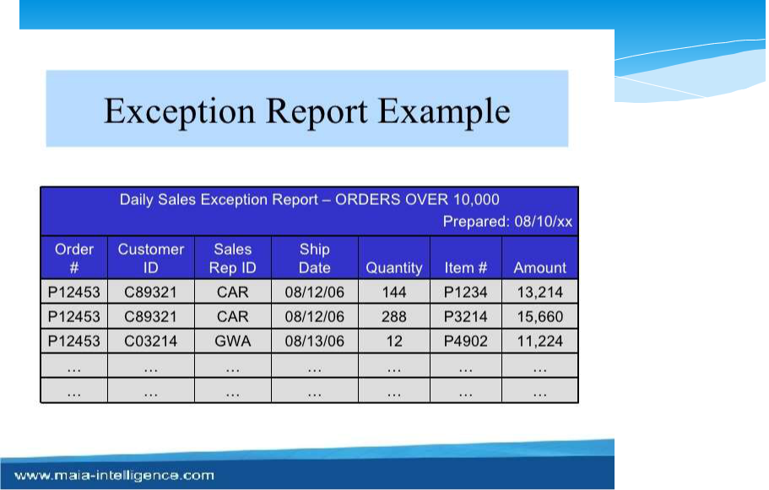
Decision Support System

A decision support system (DSS) is a computer program application that analyzes business data and presents it so that users can make business decisions more easily. It is an "informational application" (to distinguish it from an "operational application" that collects the data in the course of normal business operation).Typical information that a decision support application might gather and present would be:


Comparative sales figures between one week and the next Projected revenue figures based on new product sales assumptions

The consequences of different decision alternatives, given past experience in a context that is described

A decision support system may present information graphically and may include an expert system or artificial intelligence (AI). It may be aimed at business executives or some other group of Knowledge workers
Characteristics of Decision support system

Provides rapid access to information
Handles large amount of data from different sources
Provides report and presentation flexibility

Offer both textual and graphical orientation Support drill down analysis
Perform complex ,sophisticated analysis aqnd

comparisons using advanced s/w
Activities in decision support system

What if analysis
Sensitivity analysis
Goal seeking analysis
Optimization analysis
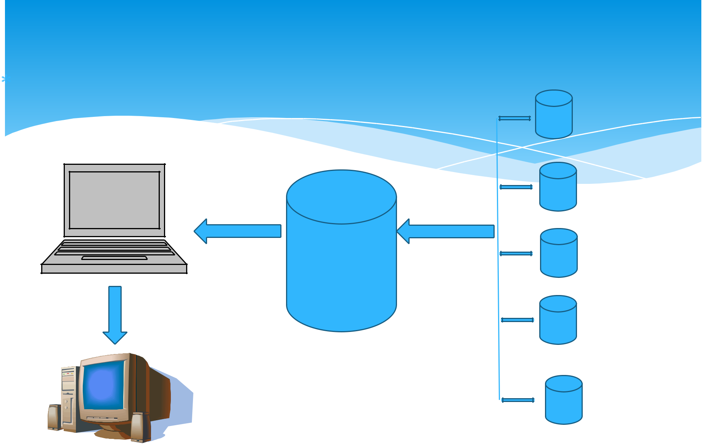
VOYAGE-ESTIMATING DECISION SUPPORT SYSTEM

PC

Analytical
Models
database

Ship file eg
speed,capacity

Port distance
Restriction file

fuel
consumption
cost file

Ship charter hire
history cost file

Port expense
file

Online
queries


DSS:Example

Voyage estimating system calculates financial and technical voyage details. It is based on analytical models.
Financial calculations include :

ship/time costs(fuel, labor, capital) ,freight rates for various types of cargo and port expenses
Technical details include factor as:

ship cargo capacity, speed ,port distances ,fuel and water consumption and loading patterns ( locations of cargo for different ports

cont

The system can answer questions such as:

- Given a customer delivery schedule and an offered freight rate, which vessel should be assigned at what rate to maximize profits?

- What is the optimal speed at which a particular vessel can optimize its profit and still meet its delivery schedule?

- What is the optimal loading pattern for a ship bound for US west coast from Malaysia?
DSS : Intrawest(largest Ski operator in north America

- The system is not not model driven , focusing instead on extracting useful information to support decision making from massive quantities of data.

- It uses special software to analyze these data to determine the value , revenue potential and loyalty of each customer so managers can make better decisions on how to target their marketing programs

- The system segments the customers into categories from

“passionate experts” to “ value – minded family vacationers “ etc

- The company then emails video clips that would appeal to each segment to encourage more visits to its resort
EXECUTIVE SUPPORT SYSTEMS FOR SENIOR
MANAGEMENT

Issues at senior Management level:
What will employment be in 5 yrs ?

What are long term industry cost trends , where does our firm fit in?
What products should we be making in next 5 yrs?

What new acquisitions would protect us from cyclical business swings ?
Characteristics of ESS

Are tailored to individual executives Are easy to Use
Have drill down abilities
Support the need for the external data

Can help with situations that have high degree of uncertainty
Have a future orientation
Are linked with value added business processes
Role of ESS

- Addresses non routine decision requiring judgement , evaluation, and insight

- Presents graphs and data from many sources through an interface that is easy for senior managers to use

- Incorporates data about external events such as new tax laws or competitors ,but also draws a summarized information from internal MIS and DSS

- It filters ,compresses and track critical data , displaying that data of greatest importance to senior managers.

MODEL OF AN EXECUTIVE SUPPORT SYSTEM

ESS
Workstation/Portal

 | • | Menus
 | • | Graphics
ESS | • | Communications
ESS | • | Digital Dashboards
Workstation/Portal | •


 |  | Internal data | External data
 |  | TPS/MIS data | Dow Jones
 |  | Financial data | Internet news feeds
 |  | Office systems | Standard & Poor
• Menus |  | Modelling/analysis
- Graphics

- Communications
- Digital Dashboards

ESS

Workstation/Portal

- Menus
- Graphics
- Communications
- Digital Dashboards



INFORMATION SYSTEMS FOR

BUSINESS FUNCTIONS

Marketing Information system

Marketing information system (MKIS) is a computer based system that works in conjunction with other functional
information systems to support the firm’s management in

solving problems that relate to marketing of firms products.The role of (MKIS) is to assess
The marketing managers information needs

Develop the framework for collecting information and distribute the information gathered to the end users in time
MIS generally carries out marketing need analysis,planning

- implementation and control functions of marketing managers
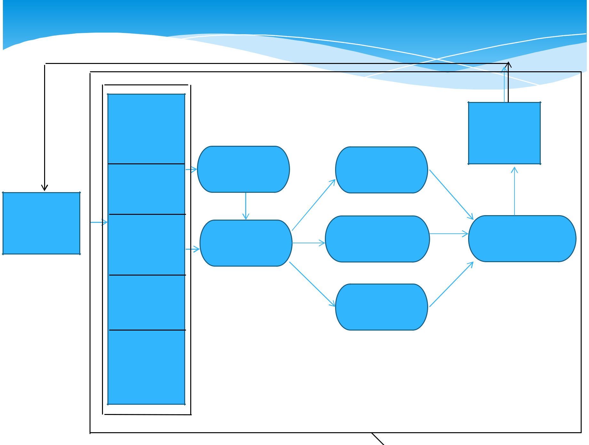
Marketing Information system

 | Data bank
 | Transaction |  |  | Other
 | Processing |  |  | areas
 | data |  |  | Of firm
 |  | Budget | Place | Of firm
 | Marketing | allocation | planning
 | Research
External | data
External | Marketing |  | Promotional | Sales
environment | Marketing | Product | Promotional | Sales
 | Intelligence | Product | planning | forecasting
 | Intelligence | planning | planning | forecasting
 | data | planning | planning | forecasting
 | External |  | Price
 | Environment |  | Price
 | data |  | planning
 | Strategic
 | plan


Input of marketing management systems

- Transaction processing data 

- Marketing research data

- Marketing intelligence data

- External environment data

- Strategic plan

Output of Marketing information system

Product planning

Place planning

Promotion


Price


Budget

Allocation

Sales forecast

Human resource Information System

The Human Resource Information System (HRIS) is a software or online solution for the data

entry, data tracking, and data information needs of the Human Resources, payroll, management, and accounting functions within a business.
he HRIS that most effectively serves companies tracks:
Attendance and PTO use,
Pay raises and history,

Pay grades and positions held, Performance development plans,
training received,
Disciplinary action received,

personal employee information, and occasionally, management and key employee succession plan,
High potential employee identification, and
applicant tracking, interviewing, and selection.

HRM Information Systems

HRM
Information
Systems

 |  |  | Staffing |  |  | Training and |  |  | Compensation
 |  |  | Staffing |  |  | developement |  |  | Administration
•
• | Strategic system | HR planning |  |  | Succession planning |  |  | Contract costing
 |  |  |  |  |  |  |  | salary forecasting
 |  | labour force tracking |  |  | performance Appraisal
 |  |  |  |  | planning
• | Tactic system | Lobour cost budget |  |  | Training effectiveness |  |  | Compensation effectiveness
 |  |  |  |  |  |  |  | benefit preference analysis
 |  | Analysis turn over |  |  | Career matching
 |  |  | analysis
• | Operations system | recruiting |  |  | Skill assessment |  |  | Payroll control
 |  | work force planning/ |  |  | performance evaluation |  |  | Benefits Administration
 |  | scheduling

Accounting Information Systems

 An Accounting Information System (AIS) is the system of records a business keeps to maintain its accounting system. This includes the purchase , sales , and other financial proceses of the business. The purpose of an AIS is to accumulate data and provide decision makers ( investors , creditors , and managers ) with information to make decisions.
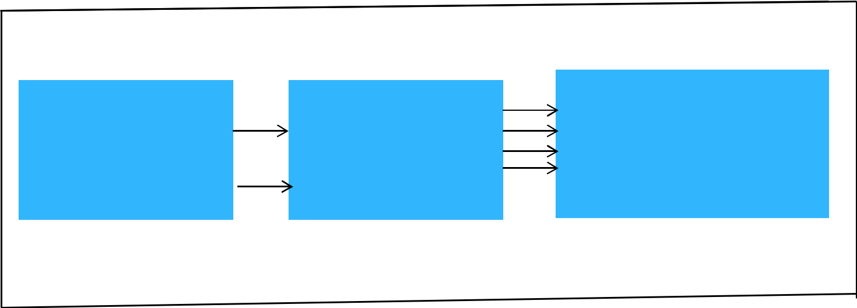

Inputs |  | processes |  | outputs
 |  |  |  | Financial statement
Transaction data |  |  |  | Financial statement
 |  | Accounting |  | Invoices
Amendments to |  | System |  | Receipts
Amendments to |  | System |  | Management information
data |  |  |  | Management information

AIS studies structuring and operation of planning and control processes which are aimed at

Providing information for decision making and accountability to internal and external an stakeholder that complies with specified quality criteria

Providing the right condition for sound decision making Ensuring that no assets illegitimately exit that organization
Types of Accounting IS

General ledger systems
Asset Management
Order-entry system
Account receivables and payable system
Inventory control system
Payroll system
Cash management
Accounting Information Systems

The Accounting Information System (AIS) performs the firm’s accounting applications . A high volume of data processing characterizes these applications . Data processing consists of four major tasks – data gathering , data manipulation , data storage , and document preparation

 AIS is data oriented rather than information oriented , and the data is largely historical
 Although the AIS is data oriented, it does produce some information .In addition

- it provides the database that serves as the foundation for other CBIS subsystems
Financial Information System

The term Financial Information System is used to describe the CBIS subsystem
That provide information to persons and group both inside and outside
the firm concerning the firm’s financial matters . Information is provide

in the form of periodic reports , special reports , and results of mathematical simulation , electronic communication , and the advice of expert systems

A financial MIS provides financial information not only for executives but also for a broader set of people who need to make better decision on a daily basis. Financial MISs is used to streamline reports of transactions.
Features of financial Information system

User friendly interface
Divisionalized reporting
Consolidated reporting
Modular structure
Automatic interface
Flexible account numbering
G/L control accounts
Flexible report formats
Installation options
Generative

security
Functions of financial IS

Most financial MIS’s perform the following functions:

Integrate financial and operational information from multiple sources including internet , into a single system
Provide easy access to data for both financial and non financial users

- often through the use of a corporate intranet to access corporate web pages of financial data and information

Make financial data immediately available to shorten analysis turnaround time

Enable analysis of financial data along multiple dimensions – time ,geography , product , plant and customer

Analyze historical and current financial activity Monitor and control the use of funds over time
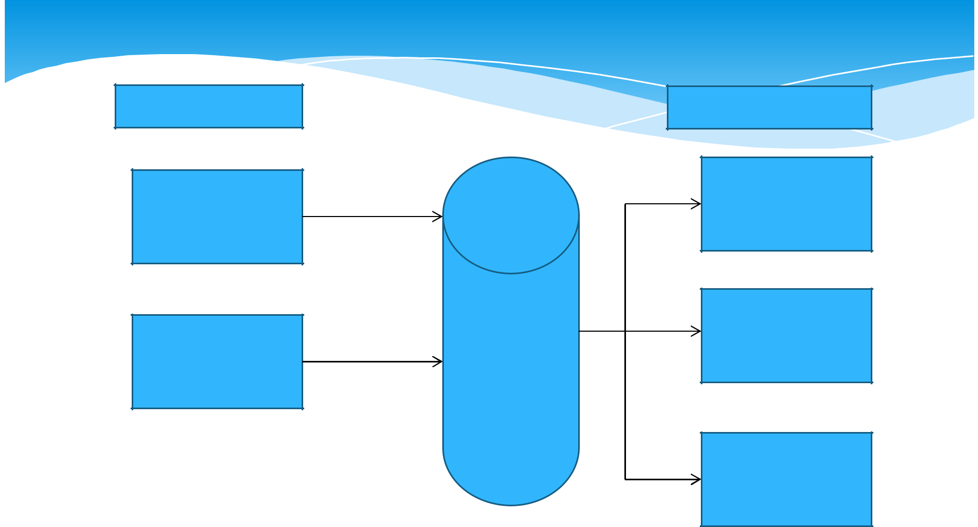
Financial information system

Input subsystem | output subsystem

Internal audit
subsystem

Financial
intelligence
subsystem

Forecasting
subsystem

 | Fund
Data | management
Data | subsystem
base | subsystem

Control
subsystem

 |  | information
data |  | information

System Analysis and Design

The overall process by which information systems are designed and implement within organizations is referred to as System analysis and design ( SA &D).Within this process are contained activities that include idedentification of business problems ; the proposed solution , in the form of an information system (IS ) , to one or more of the problems identified ; and the design and implementation of that proposed solution to achieve the desired and stared goals of the organization
The system development life cycle

One of the methods of using the systems approach to develop information system solutions , and the most prevalent one in the organization system analysis and design , can be viewed as multistep , iterative process called the systems development life cycle (SDLC)
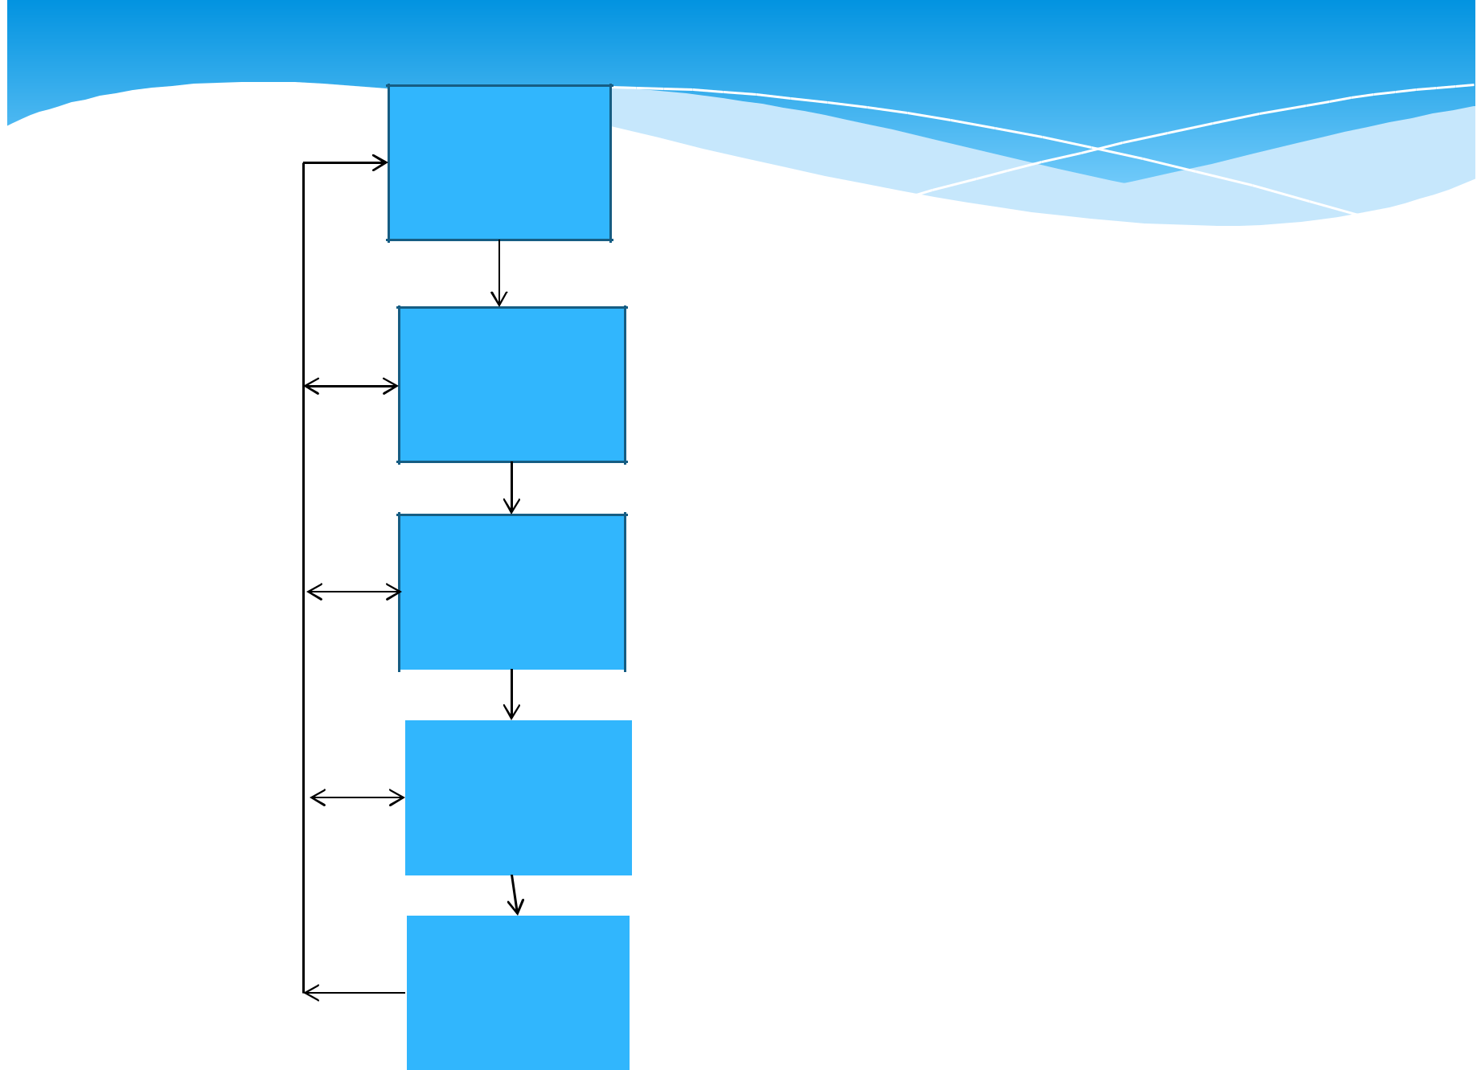 | Systems |  |  |  | • Determine how to address business opportunities and priorities
 |  |  |  |  | • Conduct feasibility study to determine whether a new or
Understand the | Investigation |  |  |  |  |  | improved business is a feasible solution
business | Product: |  |  |  | • Develop a project management plan and obtain management
problem or | Feasibility study |  |  |  |  |  | approval
opportunity
 |  |  |  |  | • Analyze the information needs of employees , customers , and
 | System |  |  |  |  |  | other business stakeholders
 |  |  |  |  | • Develop the functional requirements of a system that can meet
 | Analysis
Develop an |  |  |  |  |  |  | business priorities and need of all the stakeholders
Develop an | Product: |  |  |  |  |  | business priorities and need of all the stakeholders
Information |  |  |  |  | • |  | Develop logical models of current system
Information | Functional |  |  |  |  |  | Develop logical models of current system
system
system | requirement
solution |  |  |  |  | • Develop specifications for the hardware
 |  |  |  |  |  |  | , software, people, network , and data resources , and the
 | System |  |  |  |  |  | information products that will satisfy the functional requirements
 | Design |  |  |  |  |  | of the proposed business information system
 | Product: |  |  |  | • Develop logical models of new system
 |  |  |  | System |  | • Acquire (or develop) hardware and software
 |  |  |  | specifications
 |  |  |  |  |  | • Test the system , and train people to operate and use it
Implement the
 |  |  |  |  |  | • Convert to the new business system
information
 |  |  |  | System |  | • Manage the effects of system changes on end users
system
 |  |  |  | Implementation
solution
 |  |  |  | Product: |  | • Use a post implementation review process to monitor , evaluate
 |  |  |  | Operational |  | and modify the business system as needed
 |  |  |  | system
 |  |  |  | System
 |  |  |  | Maintenance
 |  |  |  | Product:
 |  |  |  | Improved system

Feasibility study
Operational feasibility

how well the proposed system supports the business priorities of the organization
How well the proposed system will solve the identified problem

How well the proposed system will fit with the existing organizional structure
Economic feasibility

Cost saving, increased revenue , decreased investment requirement, increased profit ,cost benefit analysis
Technical feasibility
Hardware ,software , and network capability ,reliability and availability
Human Factors Feasibility

Employee, customer ,supplier acceptance , management support ,determining the right people for the various new or revised roles
Legal/Political feasibility

Patent , copyright and licensing , government restrictions , affected stakeholders and reporting authority

Systems analysis

System analysis is not a preliminary study; however it is an in depth study of end user information needs that produces functional requirements that are used as the basis for the design of a new information system.System analysis traditionally involves a detailed study of:
The information needs of a company and endusers like yourself

The activities , resources , and products of one or more of the present information system being used

The information system capabilitiesrequired to meet your information needs , and those of other business stakeholders that use the system

Important steps for System analysis

Organizational analysis  Analysis of the present system

Logical analysis


Functional requirement analysis and determination

Examples of Functional requirement for
proposed e commerce system for a business

Examples of Functional requirements

- USER FRIENDLY INTERFACE
- Automatic entry of product data and easy to use data entry
screens for web customers

- PROCESSING REQUIREMENTS
- Fast , automatic calculation of sales totals and shipping costs

- STORAGE REQIREMENTS
- Fast retrieval and update of data from product , pricing and
customer data base

- CONTROL REQUIREMENTS
- Signals for data entry errors and quick email confirmation for
customers
Eg of the functional requirements for the
proposed e commerce system

User interface requirement

Automatic entry of product data and easy to use data entry screens for web consumers
Processing requirement
Fast, automatic calculation of sales totals and shipping costs
Storage requirements

fast retrieval and update of data from product , pricing , and customer daabases
Control requirements

Signals for data entry errors and quick email conformation for customers

System design

Once the analysis portion of the life cycle is complete , the process of system design can begin . here is where the logical model of the current system is modified until it represents the blueprint for the new system.

 Focus is on how the system will accomplish its objectives. This is where issues related to hardware , software

- networking , data storage , security , and many others will be discussed and determined .

As such system design consists of design activities that ultimately produce physical system specifications satisfying the functional requirements that were developed in the system analysis process.

System design

System Design

 |  |  |  | Process
User interface |  | Data design |  | Process
design |  | Data design |  | design

Screens ,Form | Data element | Program and
Screens ,Form | Data element | Procedure design
, Report, and dialog | Structure design | Procedure design
design


Useful guideline for the design of business web sites
 Remember the customers

Successful web sites are built solely for the customers, not to make company VP happy
Aesthetics

Successful designs combine fast loading graphics and simple color palettes for pages that are easy to read
Easy to navigate

Make sure it’s easy to et from one part of your site to another. Providing a site map , accessible from every page
Searchability


Many sites have their own search engines , very few are actaully useful.make sure yours is
Incompatibilities


A site that looks great on a PC using IE can often look miserable on an Ibook running Netscape
 Registartion forms

Registration forms are a useful way to gather customer data.But make your customers fill out three page form and watch them flee
 Dead links

Dead links are the bane of all web surfers – be sure to keep your links up dated.many web design s/w tolls can now do tis for you

System Implementation

The system implementation stage involves hardware and software acquisition , software development , testing of programs and procedures , conversion of data resources , and a variety of conversion alternatives.

It also involves the education and training of end users and specialists who will operate a new system.

Implementation can be difficult and time consuming process , however it is vital in ensuring the success of any newly developed system .Even a well designed system will fail if it not properly implemented which is why the implementation process typically requires a project management effort on part of IT and business unit managers
Evaluating hardware, software, and services
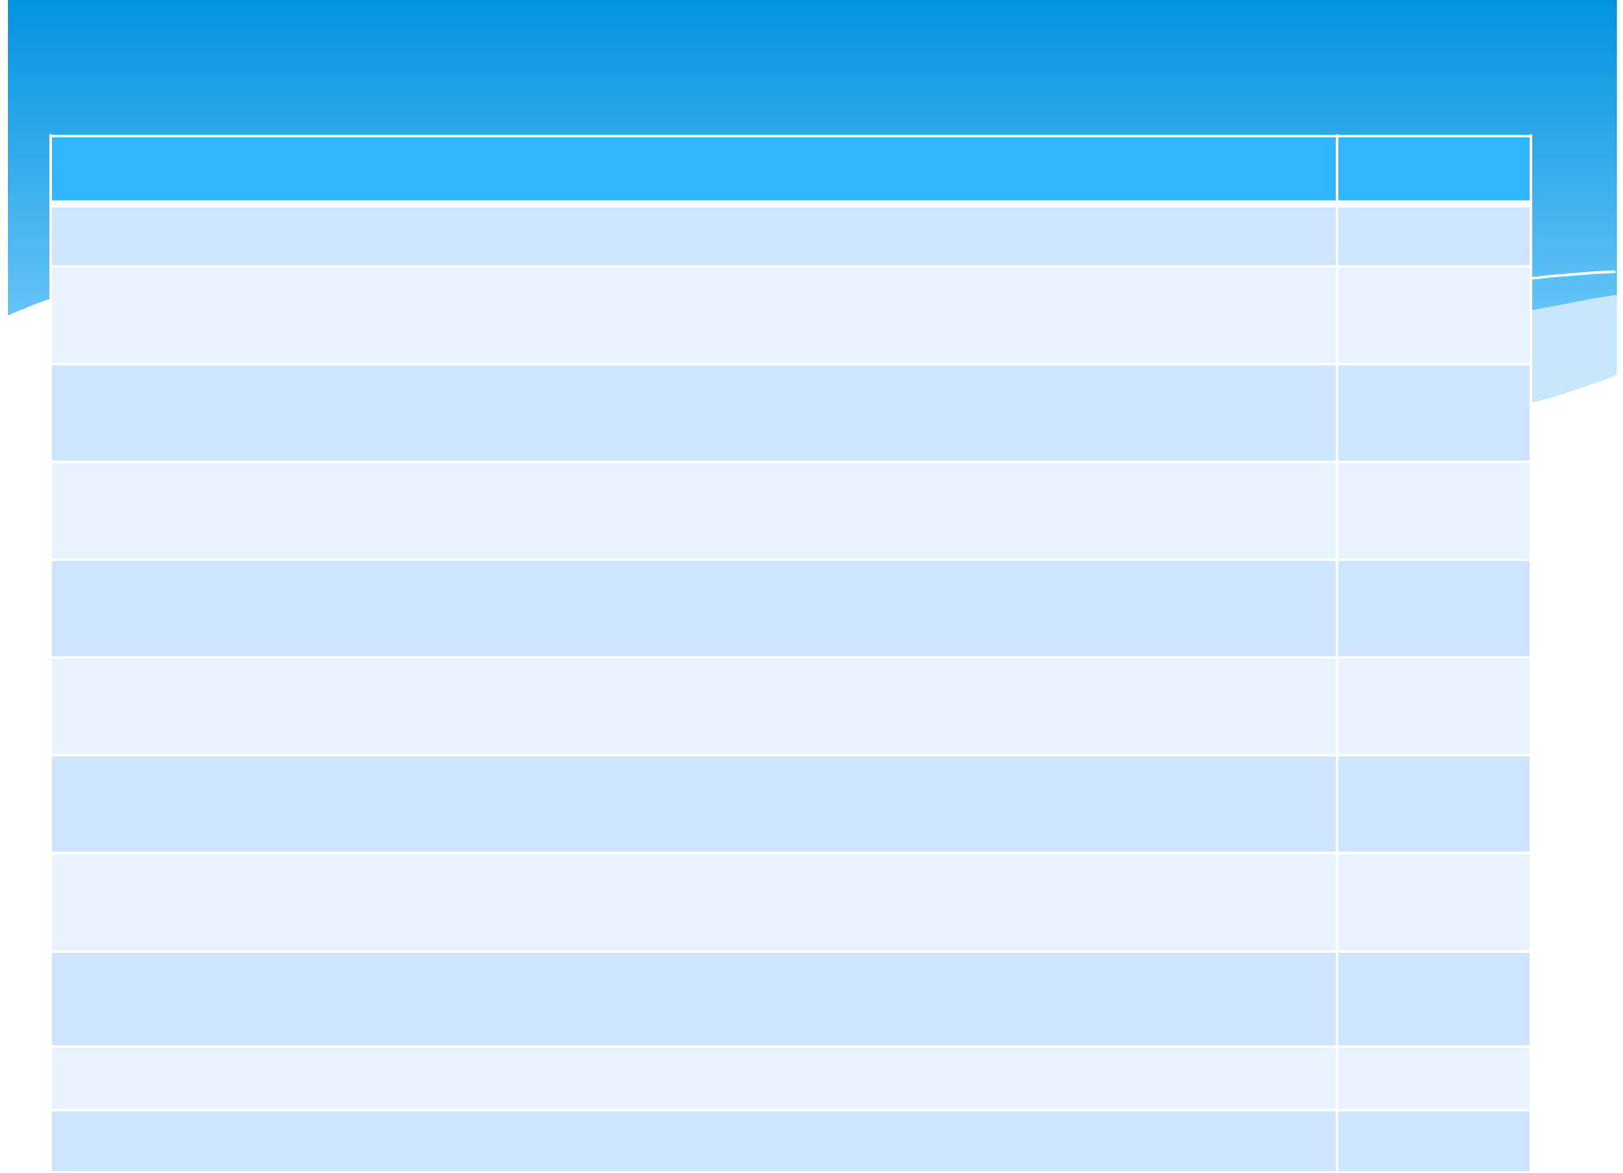

Hardware Evaluation factors | Ratings
PERFORMANCE: What is its speed, capacity and throughput
COST : What is its lease or purchase price ? What will be its cost of operation and
maintenance ?
RELIABILITY ; What are the risk of malfunction and its maintenance requirements? What
are its error control and diagnostic features?
COMPATIBILITY : Is it compatible with existing hardware and software? Is it compatible
with hardware and software provided by competing suppliers?
TECHNOLOGY:does it used a new untested technology , or does it run the risk of
obolescence?
ERGONOMICS:Has it been “human factors engineered” with the user in mind ?Is it user | en
friendly,designed to be safe , comfortable , and easy to use?
CONNECTIVITY:Can itbe easily connected to wide area and local area networks that use
the different types of network technologies and bandwidth altenatives
SCALALBILITY:Can it handle the processing demand of a wide range of end users
,transactions , queries , and other information processing requirements ?
SOFTWARE: Are system and application software available that can best use this
hardware?
SUPPORT:ARE the services required to support and maintain it available?

OVERALL RATING
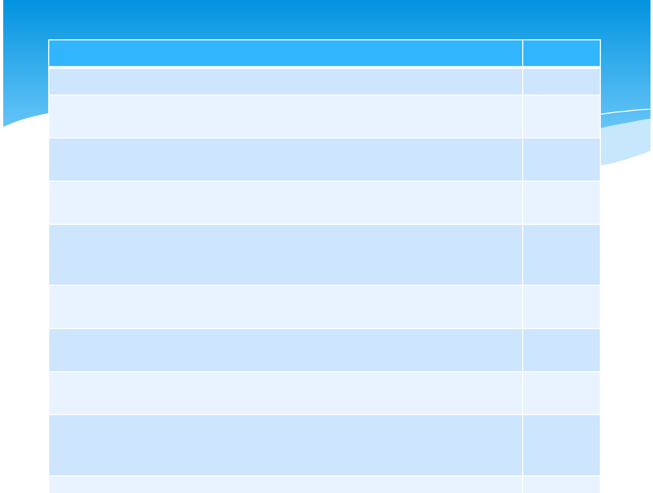
Software Evaluation factors

Software Evaluation factors | Ratings

QUALITY : Is it bug free , or does it have many errors in its program code

EFFICIENCY: Is the software , a well developed system of program code that does not use much CPU time , memory capacity , or disk space?

FLEXIBILITY: Can it handle our business processes easily , without major modifications?

SECURITY: Does it provide control procedures for errors, malfunctions , and improper use?

CONNECTIVITY:Is it web enabled so it can easily access the Internet , intranet , and etranets , on its own , or by working with WEB browsers or other network software?

MAINTENANCE:Will new features and bug fixes be easily implemented by our software developers?

DOCUMENTATION:is the software well documented ? Does it include help screens and helpful software agents?

HARDWARE:Does existing hardware have the features required to best use this software?

OTHER FACTORS: What are its performance costs, reliablility , availibility, compatibility,modulaity ,technology ,ergonomics , scalability and support characteristics ?

OVERALL RATINGS
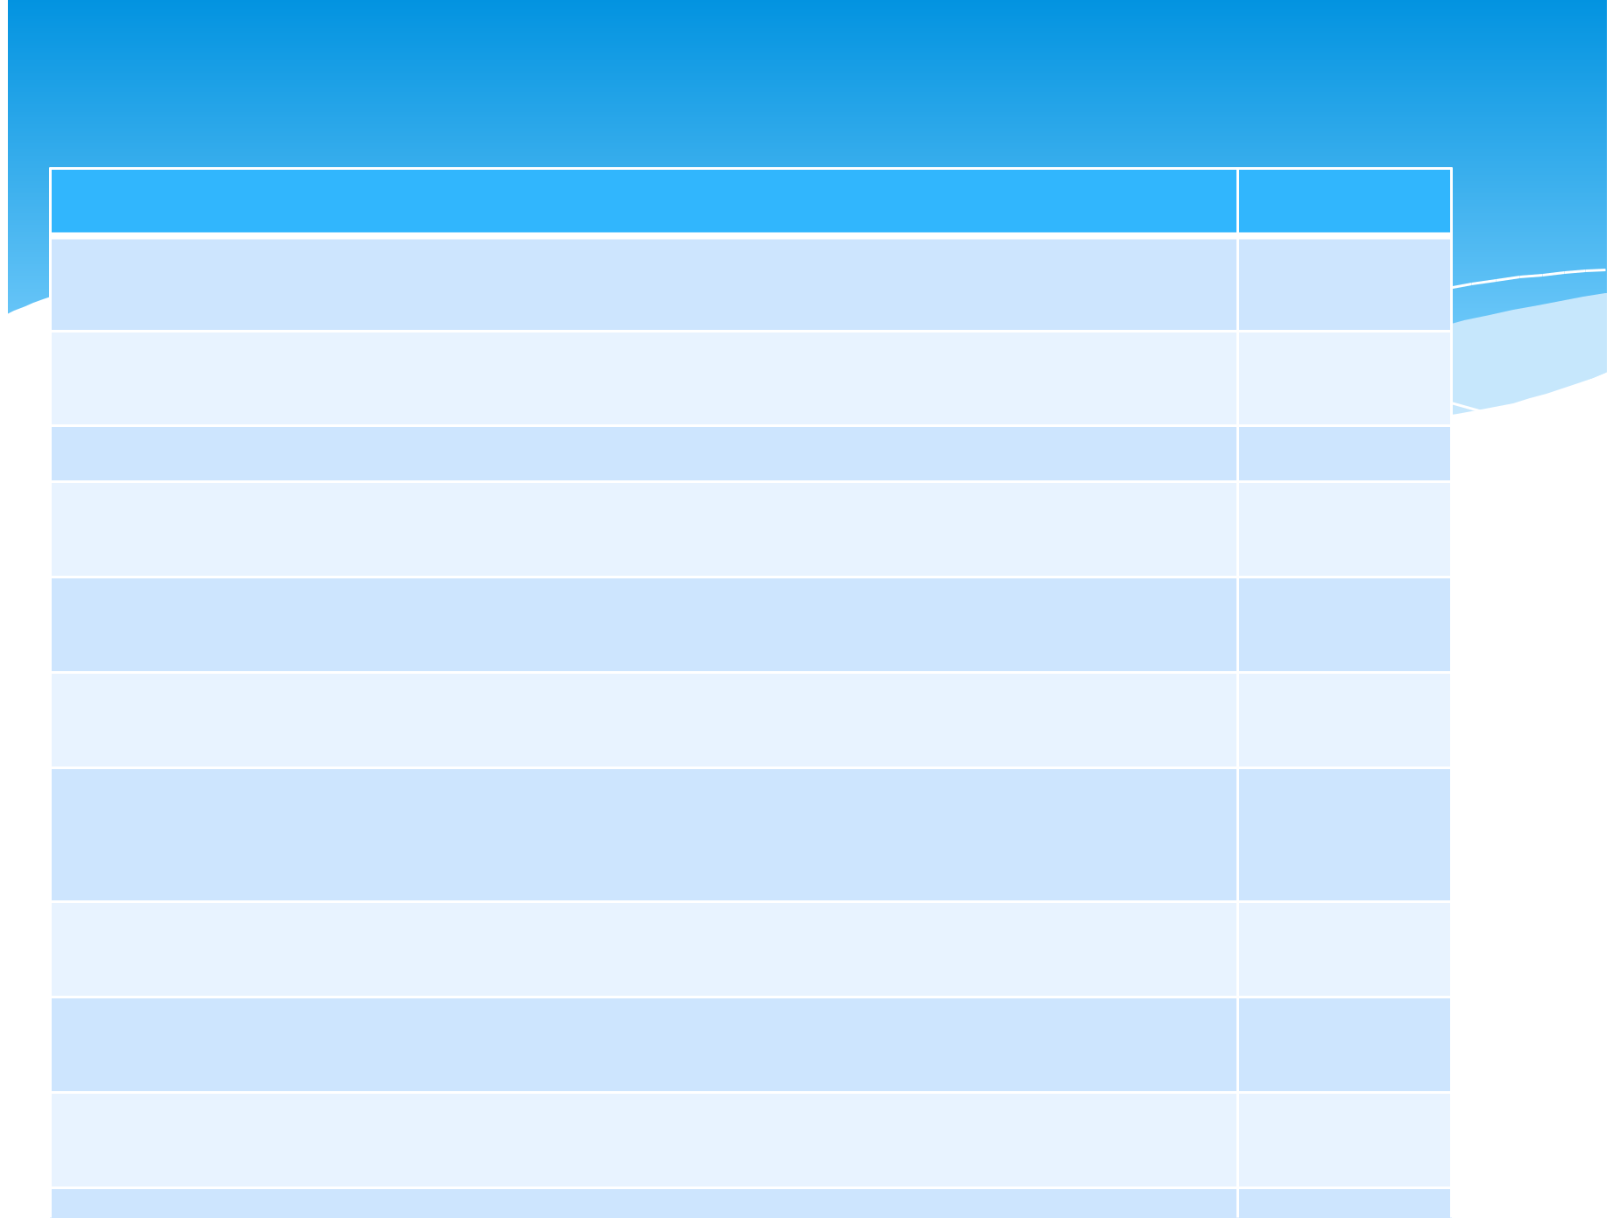
Evaluation factors for IS Services

Evaluation factors for IS Services | Rating

PERFORMANCE: What has been their past performance in view of their past promises

SYSTEMS DEVELOPMENT: Are Web site and other e- business developers available?
What are their quality and cost ?

MAINTENANCE: Is equipment maintenance provided ? What are its quality and cost?

CONVERSION : What system development and installation services will they provide during the conversion period?

TRAINING: Is the necessary training of personal provided? What are its qality and cost/

BACK UP: Are similar computer facilities available nearby for emergency backup purpose?

ACCESSIBILITY : Does the vendor provide local or regional sites that offers sales , systems development , and hardware maintenance services? Is a customer support center at the vendor’s Web site available? Is a customer hotline provided?

BUSINESS POSITION:Is the vendor financially strong , with good industry market prospects?

HARDWARE: Do they provide a wide selection of compatible hardware devices an accessories?

SOFTWARE : Do they offer a variety of e business software and application packages
OVERALL RATINGS
Other Implementation activities

Testing
Data conversion
Documentation
Training
System conversion
Post implementation
System maintenance

